Project Development Phase
Model Performance Test
Date | 02 October 2026
Team ID | SWTID-2026-7810
Project Name | Auto-Ticket Classification using Flow Designer
Maximum Marks

Model Performance Testing:
Power BI model performance testing for the Auto-Ticket Classification project is recorded in the template below.
S.No. | Parameter | Screenshot / Values
1. | Data Rendered | Dataset: ServiceNow incident export (Tickets table) - 500 tickets, 11 columns, raised by students and teachers between 03-Aug-2026 and 30-Sep-2026. Each ticket carries only Caller Name and Short Description from the user; Category and Subcategory were assigned by the Flow Designer keyword rules.  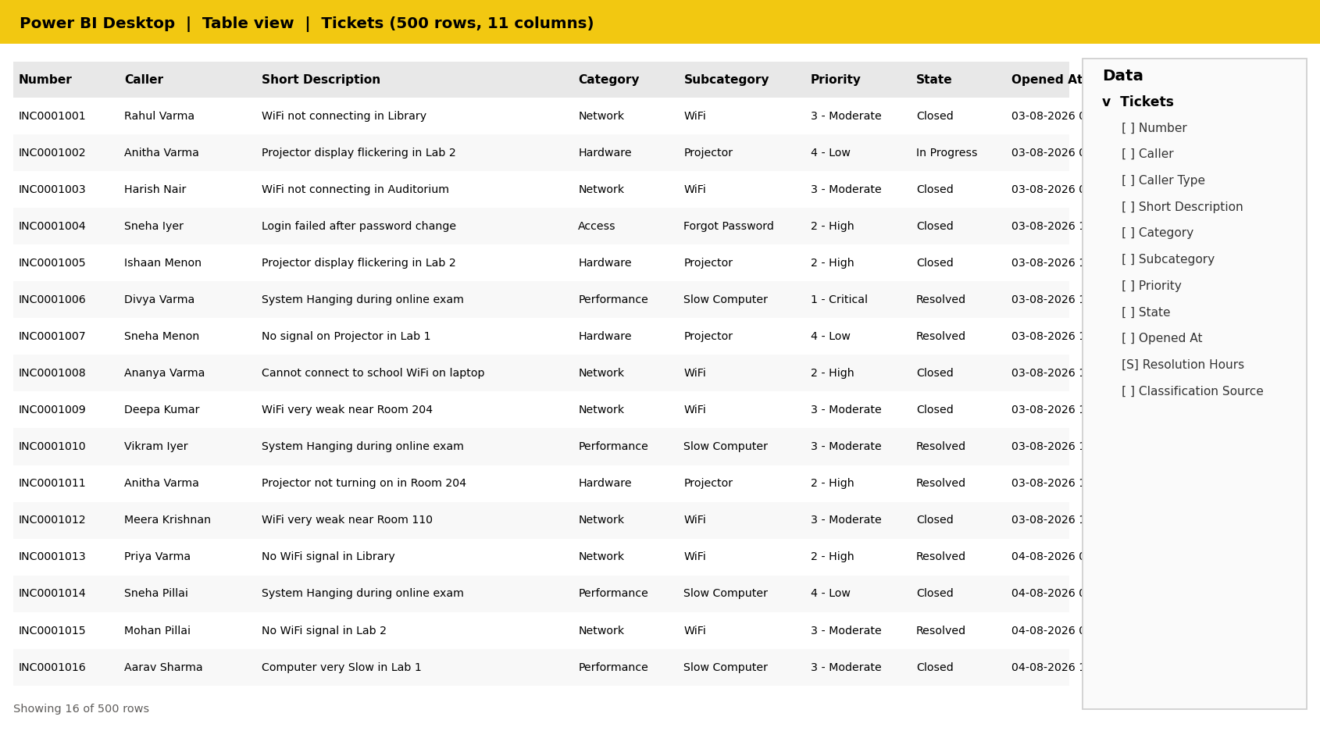  Table view of the Tickets table loaded into Power BI (first 16 of 500 rows).
2. | Data Preprocessing | Cleaning and shaping done in Power Query Editor: promoted headers, set data types, trimmed Short Description, removed duplicate ticket numbers, filtered out test tickets, replaced blank Category with "Other", and added Keyword Detected plus Date, Hour and Weekday columns. Column profiling shows 100% valid, 0% error, 0% empty for all key fields.  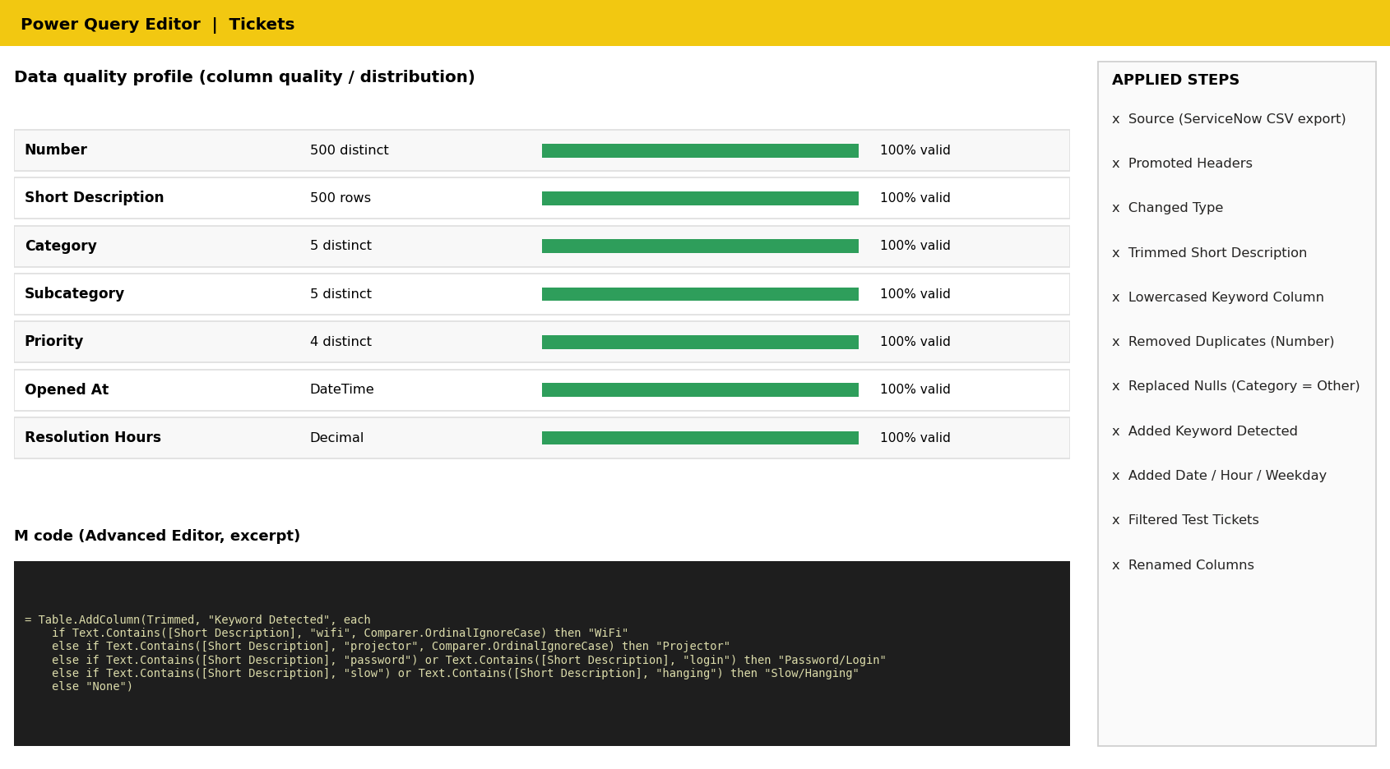
3. | Utilization of Data Filters | Slicers used: Category, Priority, Caller Type and Opened At (date range). Example shown: Category = Network and Hardware, Priority = High and Moderate, Date = September 2026, which returns 88 of 500 tickets. A page-level filter (Category <> blank) and a visual-level Top N filter on Subcategory are also applied.  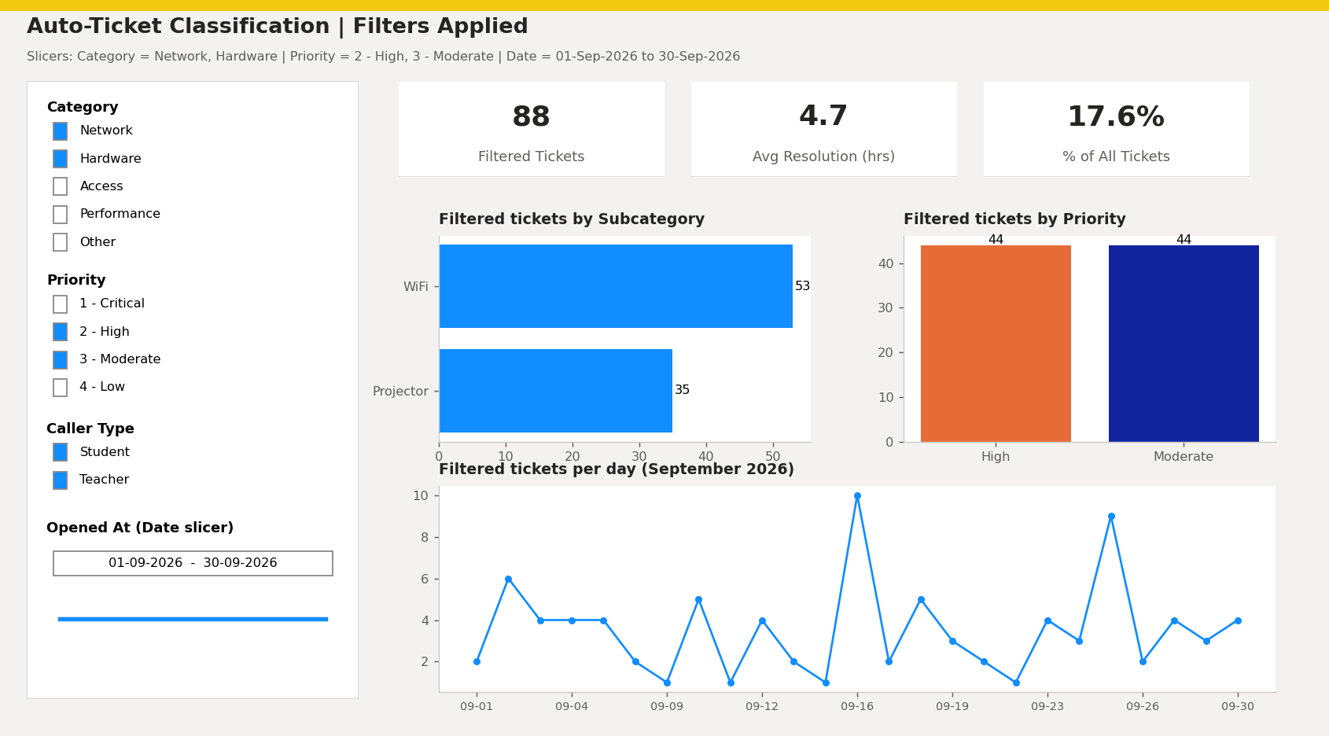
4. | DAX Queries Used | Measures and calculated column created in the Tickets model:  Total Tickets = COUNTROWS ( Tickets )  Auto Classified Tickets =  CALCULATE ( [Total Tickets], Tickets[Classification Source] = "Flow Designer" )  Auto Classification Rate % =  DIVIDE ( [Auto Classified Tickets], [Total Tickets] )  Avg Resolution Hours = AVERAGE ( Tickets[Resolution Hours] )  Open Tickets =  CALCULATE ( [Total Tickets], Tickets[State] IN { "New", "In Progress" } )  Category Share % =  DIVIDE ( [Total Tickets], CALCULATE ( [Total Tickets], ALL ( Tickets[Category] ) ) )  Tickets MTD = TOTALMTD ( [Total Tickets], 'Date'[Date] )  Manual Effort Saved (hrs) = [Auto Classified Tickets] * 3 / 60  Keyword Detected (calculated column) =  SWITCH ( TRUE (),  SEARCH ( "wifi", Tickets[Short Description], 1, 0 ) > 0, "WiFi",  SEARCH ( "projector", Tickets[Short Description], 1, 0 ) > 0, "Projector",  SEARCH ( "password", Tickets[Short Description], 1, 0 ) > 0  || SEARCH ( "login", Tickets[Short Description], 1, 0 ) > 0, "Password/Login",  SEARCH ( "slow", Tickets[Short Description], 1, 0 ) > 0  || SEARCH ( "hanging", Tickets[Short Description], 1, 0 ) > 0, "Slow/Hanging",  "None" )
5. | Dashboard design | No of Visualizations / Graphs - 10  5 KPI cards (Total Tickets, Auto-Classified, Auto-Classification Rate, Avg Resolution Hours, Open Tickets), donut chart (tickets by Category), bar chart (tickets by Subcategory), column chart (tickets by Priority), line chart (weekly trend by Category) and column chart (ticket status). In total the dashboard page holds 10 visuals (5 cards + 5 charts).  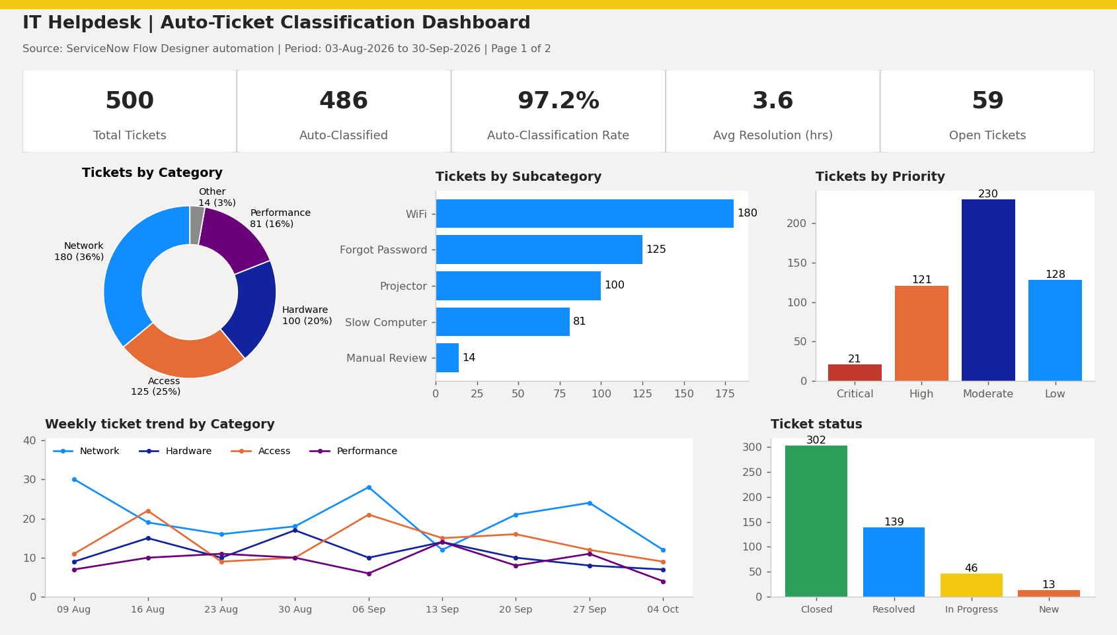
6. | Report Design | No of Visualizations / Graphs - 4  Report page 2: stacked column chart (monthly tickets by Category), bar chart (average resolution time by Subcategory), heat map matrix (weekday x Category) and a keyword-to-category table that shows how many tickets each Flow Designer rule classified.  